**head command:**

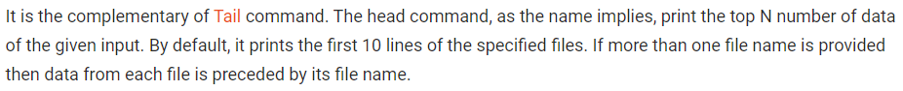

Without any option, it displays only the first 10 lines of the file specified.

* **head filename**

**options:**

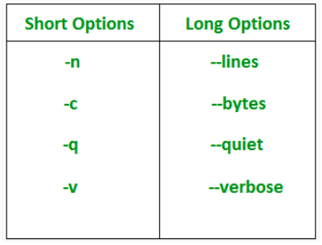

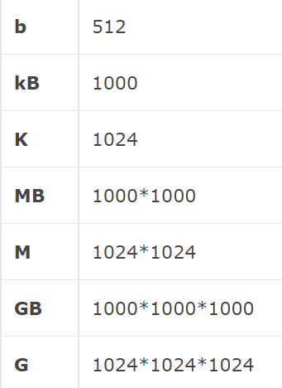

**-n num:** Prints the first ‘num’ lines instead of first 10 lines. num is mandatory to be specified in command otherwise it displays an error.



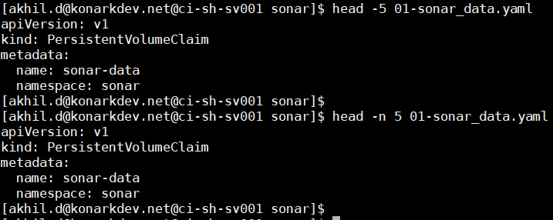



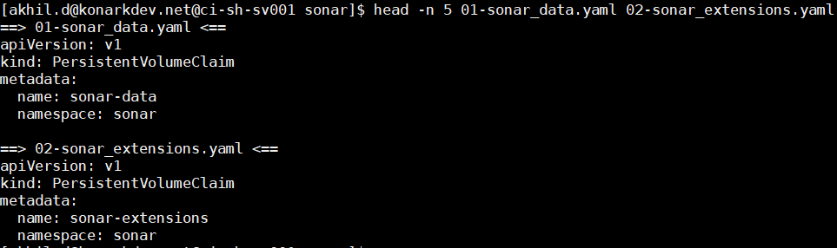

**-c num:** Prints the first ‘num’ bytes from the file specified. Newline count as a single character, so if head prints out a newline, it will count it as a byte. num is mandatory to be specified in command otherwise displays an error.



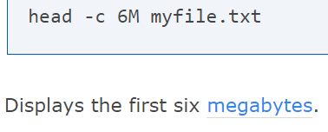

**-q:** It is used to combine the data if more than one file was given

**Without -q:**

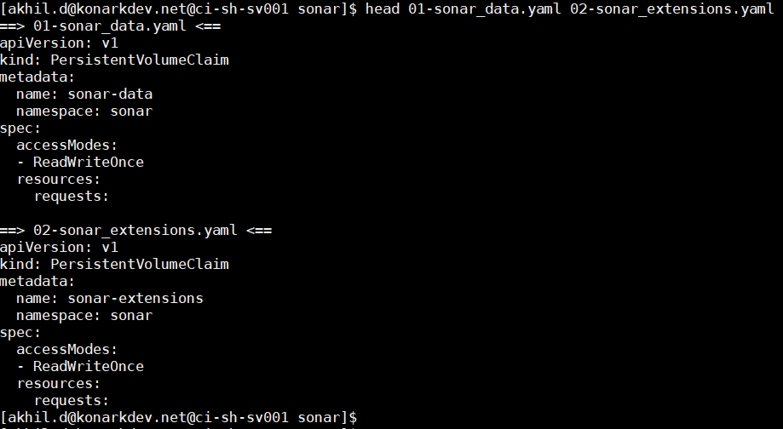

**With -q:**

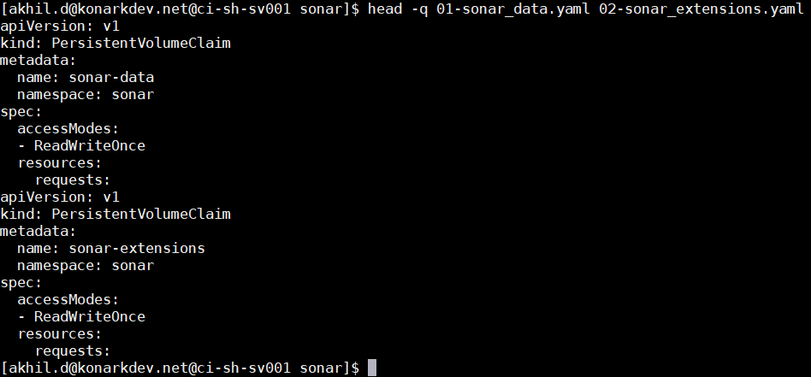

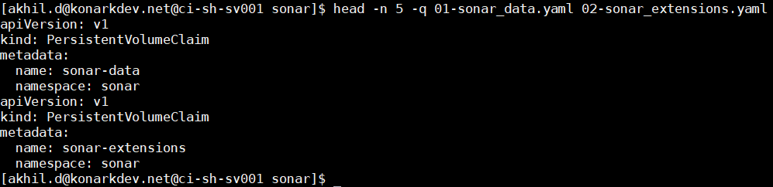

**-v:** By using this option, data from the specified file is always preceded by its file name.



**Examples:**

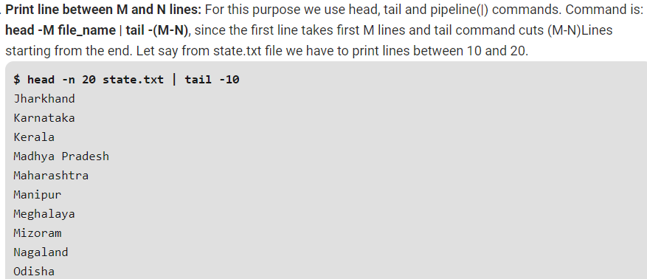

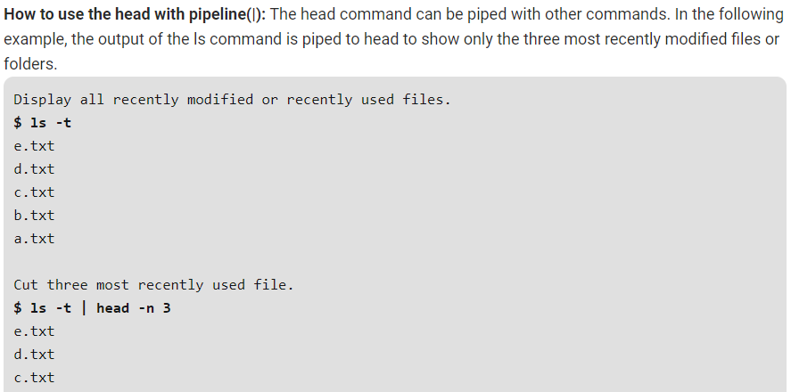

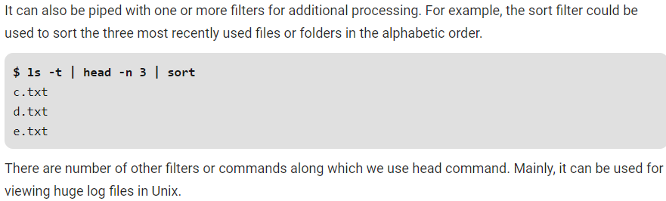

**tail command:**

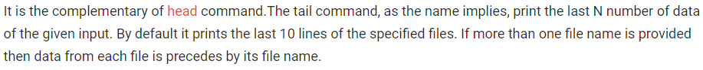

Without any option it displays only the last 10 lines of the file specified.

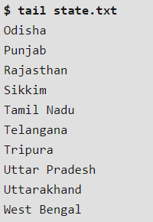

**Options:**

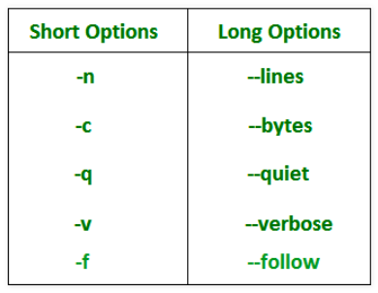

**-n num:** Prints the last ‘num’ lines instead of last 10 lines. num is mandatory to be specified in command otherwise it displays an error. This command can also be written as without symbolizing ‘n’ character but ‘-‘ sign is mandatory.

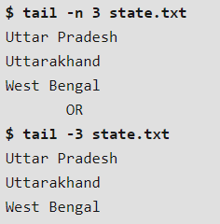

**-q:** It is used if more than 1 file is given. Because of this command, data from each file is not precedes by its file name just like in head command

* **tail -q file1 file2**

**-f:** This option is mainly used by system administration to monitor the growth of the log files written by many Unix program as they are running. This option shows the last ten lines of a file and will update when new lines are added. As new lines are written to the log, the console will update with the new lines. The prompt doesn’t return even after work is over so, we have to use the interrupt key to abort this command. In general, the applications writes error messages to log files. You can use the -f option to check for the error messages as and when they appear in the log file.

* **Tail -f file1.txt**
* **Tail -100f file1.txt**

**-v:** By using this option, data from the specified file is always preceded by its file name.

* **tail -v file1.txt**

display specific number of bytes

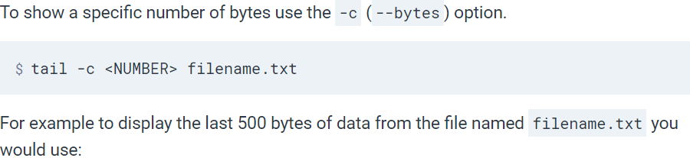

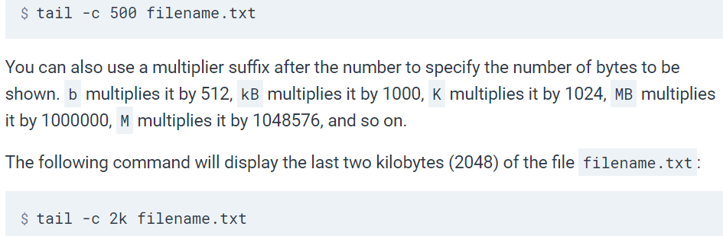

**examples:**

